Sermon Questions – A Shepherd’s Story
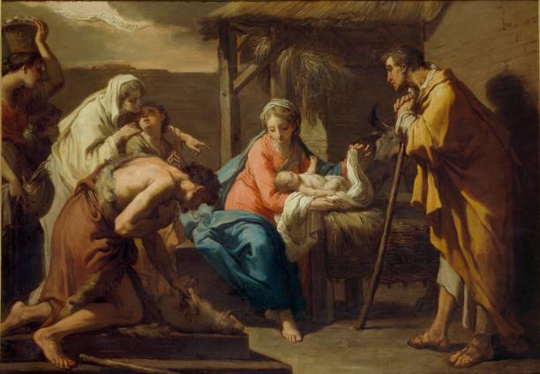
- The Shepherds were amongst the despised and rejected within society, who would be regarded as the despised and rejected in our society?
- How often do we pre-judge people by their appearance and their reputation? Are there groups of people we feel don’t belong in the church? Is there a certain moral behaviour to be adhered to in order to be part of the church?
- How can we/you address the issues of homelessness and poverty within our community?
- How can we promote a more ‘inclusive’ church?
- Have you ever felt excluded or discriminated against, and how did it make you feel?
- The shepherds did not expect to be included in God’s plan and had to go and see Jesus for themselves. Is there anything you need to search out for yourself to alleviate your misconceptions about the Christian life?

